**Database Assignment**

Use the Database Assignment #1 worksheet that you download from our course to answer the following questions. When completed, you will upload the file in MyPHSC.

1. For the two tables, identify the Primary Keys, composite primary Key and Foreign Keys?

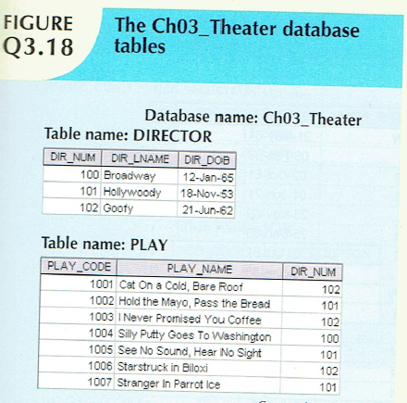

2. For each table, identify the primary key, composite primary Key and the foreign key.

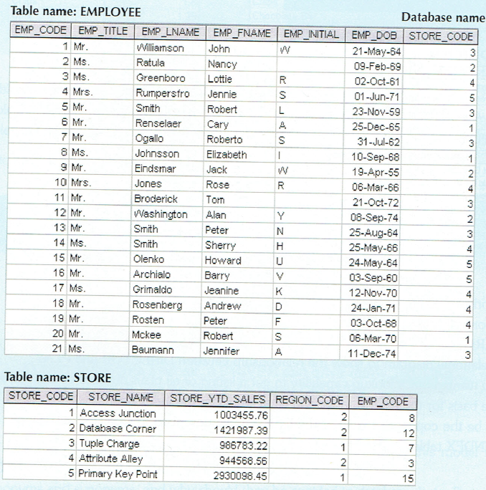 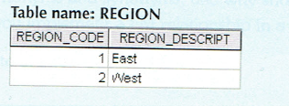

3. For each table, identify the primary key, composite primary Key and the foreign key.

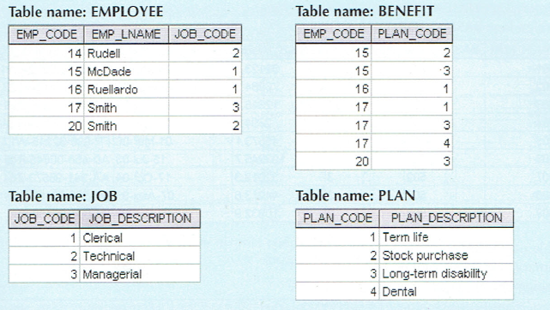

4. For each table, identify the primary key, composite primary Key and the foreign key.

Table Name: TRUCK

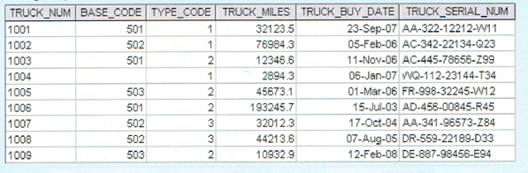

Table Name: BASE

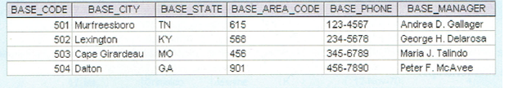

Table name Type

